1)Check for TL:DR ,ELI -15 in prompting and see the difference in output
Prompt: Explain Concept of Playwright Automation using Typescript
Response:
- Includes detailed concept of Playwright Automation using Typescript
- Core Components of Playwright Automation
- How it works and its key features with example codes
Using TL:DR
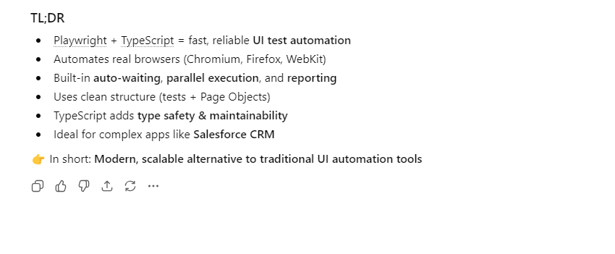
Using ELI -15
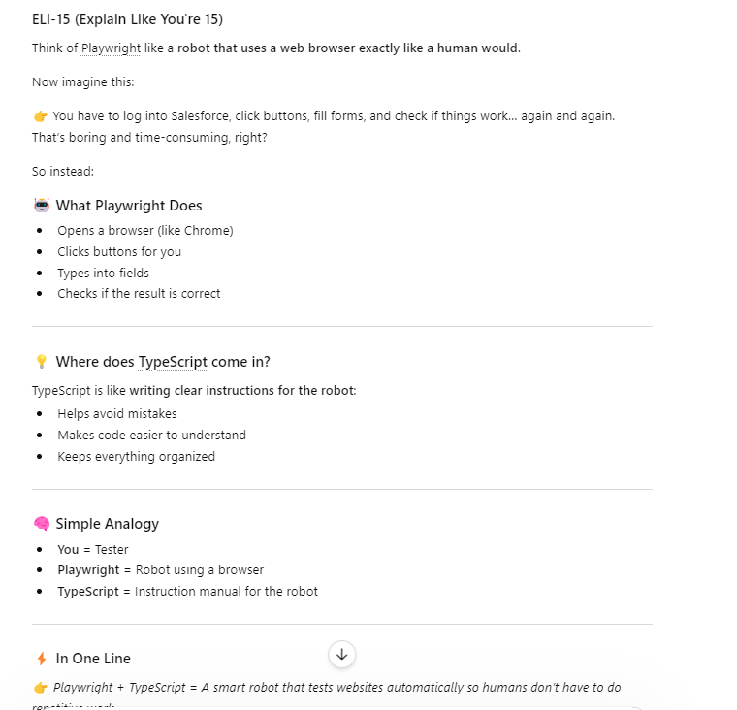
Using ELI-25 Test Engineer
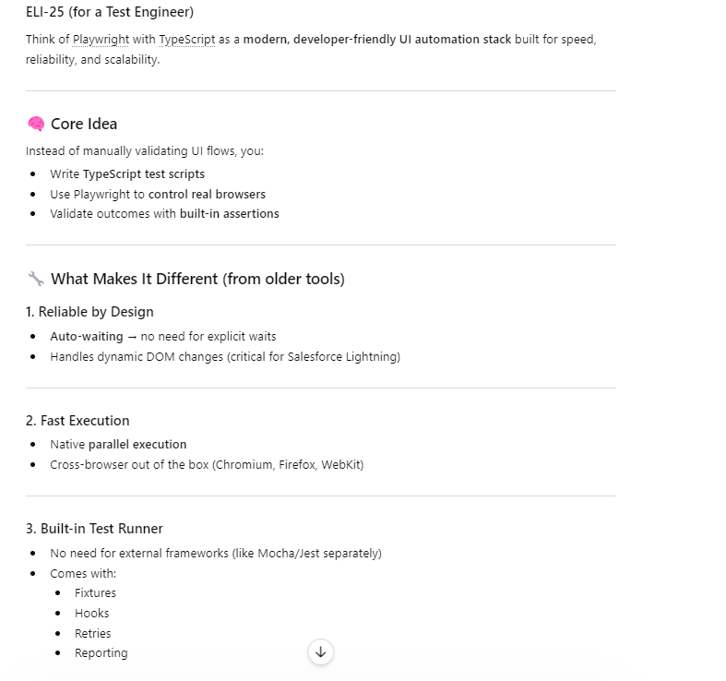
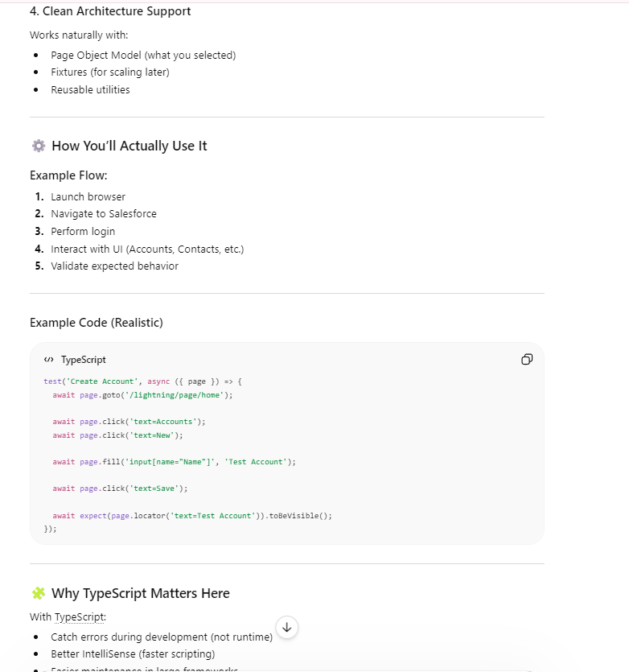
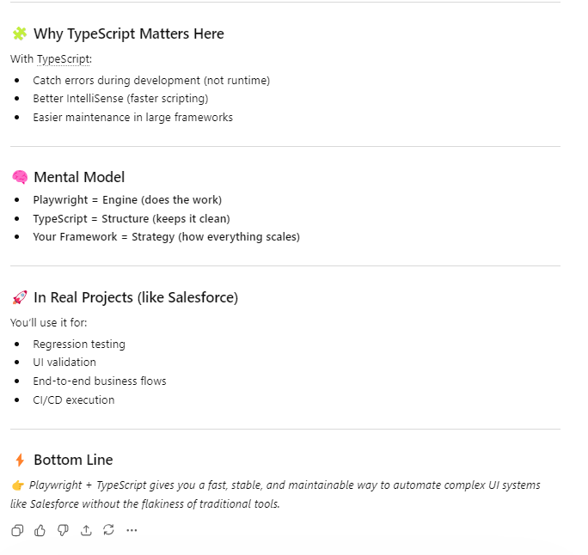

2) Using chain of thoughts
a)Generate automation framework architecture
Act as an Automation Architect to design the framework for Playwrite Automation with Typescript

Instructions
[MANDATORY] Ask me required multiple choice questions one by one
[SHALL] consider environment as Salesforce CRM
[MANDATORY] Once after answering the first question ,proceed with net
[MANDATORY] Generate Framework Structure FirstAfter completing all the questions
[STRICT] Proceed Step by Step for framework implementation
[STRICT] Up on my approval proceed with the next step
[MANDATORY] Mention Prepared by Nandhini with designation at the end of document
[CRITICAL]Once after approving all steps generate Framework document include Framework structure and step by step implementation in .docx format
Tone
Generate in Professional way

b)Generate Test strategy document
Context
Act as a Experienced FSC Domain Test Manager
Instruction
Design a Test strategy document for New Account Opening with various Registration types including both brokerage and advisory
[MANDATORY] Execution model is based on JIRA
[MANDATORY] Ask me 5 valid multiple choice questions one by one
[STRICTLY] ONCE AFTER ANSWERING THE FIRST QUESTION Go with next question
[CRITICAL]Once after answering all questions generate Test strategy document in .docx format
Step by step
Tone
Generate document in professional way

